1. Dec and RA grids made, Full Score
2. (Smallest Circle, Full Score; Medium Circle, Half Score; Largest Circle, Quarter Score)
3. (Smallest Circle, Full Score; Medium Circle, Half Score; Largest Circle, Quarter Score)
4. (Smallest Circle, Full Score; Medium Circle, Half Score; Largest Circle, Quarter Score)
5. Galactic plane inside the yellow line : Full Score  
   Galactic plane crosses the yellow line : Half Score
6. ± 2o , Full Score  
   ± 5o, Half Score

18h 36m 56.84s

-20o00’

-10o00’

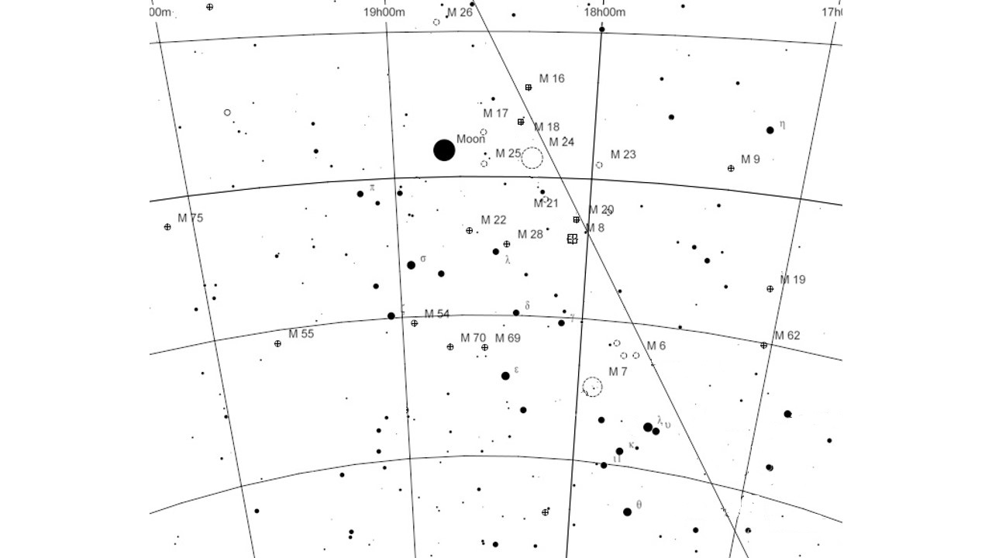

Nova Sagitarii

Galactic Plane

-40o00’

-30o00’

**4**

-28o 55’ 39.8”

**2**

**1**

**5**

**3**

Marking Messier Object

18h 36m 56.84s

-20o00’

-10o00’



Nova Sagitarii

Galactic Plane

-40o00’

-30o00’

-28o 55’ 39.8”

Messier Object

|  |  |  |
| --- | --- | --- |
| **Messier** | **Magnitudo** | **size (')** |
| 7 | 3.3 | 80 |
| 6 | 4.2 | 15 |
| 25 | 4.6 | 32 |
| 22 | 5.2 | 24 |
| 23 | 5.5 | 27 |
| 8 | 5.8 | 90 |
| 21 | 5.9 | 13 |
| 16 | 6 | 35 |
| 17 | 6 | 46 |
| 20 | 6.3 | 29 |
| 62 | 6.6 | 14 |
| 20 | 6.9 | 11 |
| 18 | 6.9 | 9 |
| 55 | 7 | 19 |
| 19 | 7.2 | 13 |
| 69 | 7.7 | 7 |
| 54 | 7.7 | 9 |
| 9 | 7.9 | 9 |
| 70 | 8.1 | 7 |
| 24 | 11 | 5 |

-20o00’

-10o00’



Nova Sagitarii

**Galactic Plane**

-40o00’

-30o00’

18h 36m 56.84s

-28o 55’ 39.8”